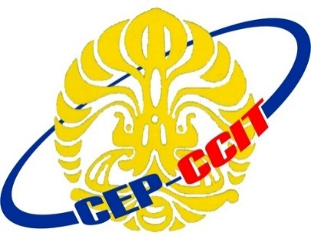

Continuning

Education

Program

Center for Computing and Information Technology

**ISAS ( Information Search and Analysis Skill)**

**“Oculus Rift as Virtual Reality Revolution”**

Name :

♦ Anindya Putri Erniandara

♦ Melinda N.P.D

♦ Muhammad Hudya Ramadhana

Class : 1SC2 (PNJ)